Clinic Doctor Appointment System

Submitted in partial fulfillment of the requirements of the

degree

BACHELOR OF ENGINEERING IN COMPUTER

ENGINEERING

**By**

JAI VISHWA NADAR (122A1040) SUBHASH KONAR (123A1055)

MAN MOHAN JHA (123A1060)

Supervisor

### PROF.SMRUTI VYAVAHARE



**Department of Computer Engineering**

**SIES Graduate School of Technology**

## Nerul, Navi Mumbai - 400 706

**University of Mumbai**

**(AY 2023-24)**

# CERTIFICATE

This is to certify that the Mini Project entitled **“ Clinic Doctor Appointment System ”** is a bonafide work of **Jai Vishwa (122A1040), Subhash (123A1055), Man Mohan (123A1060)** submitted to the University of Mumbai in partial fulfillment of the requirement for the award of the degree of **“Bachelor of Engineering”** in **“Computer Engineering” .**

##### Prof. Smruti VYAVAHARE

Supervisor

##### Dr. Aparna Bannore Dr. K. Lakshmi Sudha

Head of Department Principal

# Mini Project Approval

This Mini Project entitled **“**Clinic Doctor Appointment System **”** by **Jai Vishwa (122A1040), Subhash (123A1055), Man Mohan (123A1060)** is approved for the degree of **Bachelor of Engineering** in **Computer Engineering.**

#### Examiners

**1………………………………………**

(Internal Examiner Name & Sign)

#### 2………………………………………

(External Examiner name & Sign)

Date: Place:

# Contents

Acknowledgments 5

Abstract 6

List of Figures 8

List of Tables 9

List of Symbols

1. Chapter 1: INTRODUCTION 10
   1. Introduction
   2. Motivation
   3. Problem Statement & Objectives
   4. Organization of the Report
2. Chapter 2: LITERATURE SURVEY 13
   1. Survey of Existing System
   2. Limitation Existing system or research gap
   3. Mini Project Contribution
3. Chapter 3: Proposed System 15
   1. Problem statement
   2. Objectives
   3. Architecture/ Framework
4. Chapter 4: Design and Implementation 18
   1. Algorithm / Process Design/Methodology
   2. Details of Hardware & Software
5. Chapter 5: Experiment and Results 21
6. Chapter 6: Conclusion and Future work.
7. References 27

**ACKNOWLEDGEMENT**

We would like to express our thanks to the people who have helped us the most throughout our project. We are grateful to our guide Prof. Smruti V and coordinator, Prof. Suvarna Chaure for nonstop support for the project.

A special thanks goes to each other who worked together as a team in completing the project, where we all exchanged our own interesting ideas and thoughts and made it possible to completeour project with all accurate information. We also wish to thank our parents for their personalsupport and attention who inspired me to go my own way.

We also would like to thank our other faculty members for providing us with all the required resources and references for the project.

### ABSTRACT

The Clinic Doctor Appointment System (CDAS) is a modern solution facilitating seamless appointment scheduling between patients and healthcare providers. In an era of technological advancements, efficient appointment management is vital for patient access to care and clinic operations. CDAS offers an intuitive online interface streamlining booking, improving communication, and enhancing clinic efficiency. Key features include a user-friendly booking system allowing patients to easily find available slots based on preferences. Patients can schedule, receive automated confirmations, and manage appointments from anywhere. The system also provides appointment reminders, history tracking, and secure access to medical records, promoting patient engagement and treatment adherence. For healthcare providers, CDAS offers a centralized dashboard for efficient management of schedules, records, and resources. Providers can view, manage schedules, access medical history, and communicate with patients. Real-time appointment notifications empower providers to optimize workflow, reduce administrative burden, and deliver quality care. Built with cutting-edge web technologies, CDAS prioritizes data security and regulatory compliance, safeguarding patient information. In summary, the clinic doctor appointment system represents a significant advancement in healthcare appointment management, offering a user-centric, technologically advanced solution for clinics and providers. By leveraging the internet and digital communication, CDAS aims to revolutionize appointment booking, enhance clinic efficiency, and improve patient outcomes.

### LIST OF FIGURES

|  |  |  |
| --- | --- | --- |
| SR NO | FIGURE NAME | PAGE NUMBER |
|  |  |  |
| 1 | Admin page | 22 |
| 2 | User page | 23 |
| 3 | Register page | 24 |
| 4 | Doctor page | 25 |

## Chapter-1

### INTRODUCTION

##### Introduction

The clinic doctor appointment system (CDAS) represents a transformative solution in healthcare appointment management, catering to the evolving needs of patients and healthcare providers. In the face of traditional appointment systems' challenges, such as long wait times, communication gaps, and administrative burdens, CDAS emerges as a modern platform designed to streamline the appointment scheduling process and enhance overall clinic efficiency. CDAS offers a user-friendly interface that empowers patients to conveniently search for available appointment slots based on their preferences, including preferred date, time, and healthcare provider.for healthcare providers, CDAS provides a centralized dashboard for efficient management of appointment schedules, patient records, and clinic resources. Real-time appointment notifications enable providers to optimize clinic workflow, reduce administrative burdens, and deliver personalized patient care. This report aims to delve into the development and implementation of CDAS, exploring its impact on patient experience, clinic operations, and healthcare delivery. By harnessing the power of digital technology, CDAS seeks to revolutionize the appointment booking experience, improve clinic efficiency, and ultimately, elevate the quality of patient care.

##### Movtivation

The motivation behind the clinic doctor appointment system(CDAS) stems from the growing need for streamlined healthcare services and efficient appointment management. Traditional appointment booking systems often result in long wait times, communication gaps, and administrative challenges. CDAS aims to address these issues by providing a modern, user- friendly platform that simplifies the appointment scheduling process for both patients and healthcare providers. By leveraging digital technology, CDAS seeks to improve patient access to care, enhance clinic efficiency, and ultimately, elevate the overall healthcare experience. This report delves into the specific motivations driving the development and implementation of CDAS, highlighting its potential to revolutionize appointment management in healthcare settings**.**

##### Problem Statement & Objectives Problem Statement:

Traditional methods of scheduling appointments in healthcare clinics often lead to inefficiencies, long waiting times, and communication challenges between patients and healthcare providers. These issues can result in patient dissatisfaction, missed appointments, and suboptimal clinic operations. Addressing these challenges requires a modern solution that streamlines the appointment booking process and enhances communication between patients and providers.

##### Objectives:

* + 1. Develop a user-friendly clinic doctor appointment system(CDAS) that simplifies the appointment scheduling process for patients.
    2. Implement automated features within CDAS, such as appointment reminders and real- time notifications, to improve patient engagement and reduce missed appointments.
    3. Create a centralized dashboard within CDAS for healthcare providers to efficient ly manage appointment schedules, access patient records, and communicate with patients.
    4. Ensure the security and confidentiality of patient information within CDAS, complying with healthcare regulations.
    5. Evaluate the impact of CDAS on patient experience, clinic efficiency, and healthcare delivery through user feedback and performance metrics.

##### Organization Of The Report

This report provides a comprehensive overview of the clinic doctor appointment system (CDAS), detailing its development, implementation, and evaluation:

**Introduction**: introduces the CDAS project, its objectives, and the problem statement it addresses, emphasizing the importance of efficient appointment scheduling in healthcare clinics and introducing CDAS's key features and goals.

**Literature review**: reviews relevant literature on appointment scheduling systems, digital healthcare solutions, and clinic operations, exploring existing research on challenges faced by traditional appointment systems and the potential benefits of digital solutions like CDAS. **Methodology**: describes the approach taken in developing and implementing CDAS, including software development processes, tools used, and data collection methods, providing insights into project planning and execution.

**System design**: presents CDAS's architectural design, user interface, and key features, illustrating functionality and layout with detailed descriptions, diagrams, and screenshots. **Implementation**: discusses the process of translating design specifications into a functional website, covering coding, testing, deployment, and addressing any challenges encountered during implementation.

**Results and evaluation**: evaluates CDAS's performance and effectiveness based on user feedback, system metrics, and comparison with traditional appointment systems, analyzing its impact on patient experience, clinic efficiency, and healthcare delivery.

**Discussion**: analyzes findings, discussing implications, limitations, and future directions for the CDAS project, exploring potential areas for improvement and suggesting recommendations for enhancements.

**Conclusion**: summarizes key findings, reiterating the significance of the CDAS project and highlighting its potential impact on healthcare clinics and patients, emphasizing the importance of efficient appointment scheduling and the role of digital solutions like CDAS.

## Chapter-2

### LITERATURE SURVEY

##### Survey of Existing System

The survey of existing clinic doctor appointment websites reveals a landscape where traditional appointment booking methods coexist with digital solutions. Traditional systems often involve manual processes like phone calls or in-person visits, which can lead to inefficiencies such as long wait times and scheduling errors. In contrast, digital appointment websites offer an alternative, allowing patients to book appointments online and receive automated reminders. However, these platforms may still have drawbacks, such as complex interfaces or limited integration with clinic operations and electronic medical records.

Key findings from the survey underscore the need for a modern and user-friendly appointment scheduling solution that seamlessly integrates with clinic workflows. The Clinic Doctor Appointment system (CDAW) aims to address these shortcomings by providing a comprehensive platform that simplifies the appointment scheduling process, enhances communication between patients and providers, and improves overall clinic efficiency. By leveraging digital technology and incorporating feedback from existing systems, CDAW seeks to revolutionize the appointment booking experience for both clinics and patients. Through its intuitive interface and robust features, CDAW aims to streamline the appointment booking process, reduce administrative burdens, and enhance patient satisfaction.

##### Limitation Existing System Or Research Gap

Existing clinic doctor appointment systems, both traditional and digital, exhibit limitations and research gaps:

* + 1. Accessibility: Traditional methods may exclude patients with disabilities or language barriers, while digital systems can pose challenges for those with limited internet access or technological literacy.
    2. Customization: Current systems often lack flexibility for clinics to tailor them to specific needs, hindering efficiency.
    3. Integration: Digital systems struggle to integrate seamlessly with existing workflows and electronic medical records, leading to disjointed processes and data duplication.
    4. Data Security: Concerns persist regarding patient information security and privacy,

necessitating compliance with regulations like HIPAA and GDPR.

* + 1. Patient Engagement: Despite features like appointment reminders, there's room to improve patient involvement in their healthcare. Enhancing engagement through personalized communication and educational resources could boost attendance and health outcomes.

Addressing these issues requires innovative approaches such as developing more accessible and customizable platforms, improving integration, enhancing data security, and fostering greater patient engagement. Future efforts should focus on creating efficient, user-friendly, and patient-centric appointment systems in healthcare.

##### Mini Project Contribution

The Clinic Doctor Appointment System (CDAS) contributes significantly to clinic operations and patient experience:

* + 1. **Enhanced Efficiency**: CDAS streamlines appointment scheduling, reducing administrative burden and optimizing clinic workflow.
    2. **Improved Communication**: It facilitates seamless patient-provider communication, allowing patients to book appointments online and receive updates easily.
    3. **Accessibility**: CDAS enhances access to healthcare services by providing a convenient online platform for appointment booking.
    4. **Patient Empowerment**: Patients can access personal medical records and appointment history, empowering them to take control of their healthcare journey.
    5. **Clinic Optimization**: CDAS offers a centralized dashboard for healthcare providers to manage schedules, access records, and allocate resources efficiently.

In summary, CDAS significantly improves efficiency, communication, accessibility, patient empowerment, and clinic optimization in healthcare settings.

## Chapter-3

### PROPOSED SYSTEM

##### Problem Statement

The current landscape of clinic doctor appointment scheduling is riddled with inefficiencies and challenges that hinder the seamless delivery of healthcare services. Traditional appointment booking methods, such as phone calls or in-person visits, often result in long wait times, scheduling errors, and communication gaps between patients and healthcare providers. This leads to patient dissatisfaction, missed appointments, and compromised clinic operations. Moreover, existing digital appointment systems may lack user-friendly interfaces, customization options, and integration capabilities with clinic workflows and electronic medical records (EMR) systems. This limits their effectiveness in addressing the complex scheduling needs of healthcare clinics and the diverse preferences of patients. Additionally, accessibility issues may arise for patients with disabilities, language barriers, or limited access to technology. These barriers exacerbate disparities in healthcare access and hinder patient engagement in the scheduling process. Overall, the current state of clinic doctor appointment scheduling via websites is marked by inefficiencies, communication breakdowns, and accessibility challenges. Addressing these issues necessitates the development of a modern and user-centric appointment scheduling solution that streamlines the booking process, enhances communication between patients and providers, and ensures equitable access to healthcare services. The proposed Clinic Doctor Appointment System (CDAS) aims to tackle these challenges by providing an intuitive, accessible, and feature-rich platform for appointment scheduling. By leveraging innovative technology and prioritizing user experience, CDAW seeks to revolutionize the appointment booking experience, optimize clinic operations, and ultimately improve patient outcomes in healthcare settings

##### Objectives

* + 1. **Streamline Appointment Scheduling**: Simplify the process of booking appointments for patients and healthcare providers, reducing wait times and scheduling errors.
    2. **Enhance Communication**: Improve patient-provider communication through features like automated reminders, real-time notifications, and secure messaging functionalities.
    3. **Optimize Clinic Operations**: Provide healthcare providers with a centralized dashboard for efficient management of appointment schedules, patient records, and resource allocation.
    4. **Improve Patient Experience**: Offer convenient appointment booking options, personalized communication, and access to medical records to enhance patient satisfaction and engagement.
    5. **Ensure Accessibility and Equity**: Accommodate patients with disabilities, language barriers, and limited access to technology, promoting inclusivity and reducing disparities in healthcare access.

Through these objectives, the Clinic Doctor Appointment System (CDAS) aims to revolutionize the appointment booking experience, improve communication between patients and providers, optimize clinic operations, enhance patient satisfaction, and promote equitable access to healthcare services.

##### Architecture/Framework

1. Presentation Layer: This layer consists of the user interface components that allow patients and healthcare providers to interact with the system. It includes web pages, forms, and graphical elements designed for easy navigation and accessibility.
2. Application Layer: The application layer contains the business logic and functionality of the Clinic Doctor Appointment Website. It processes user requests, handles appointment scheduling, and manages data validation and business rules.
3. Data Layer: This layer is responsible for managing the storage and retrieval of data used by the Clinic Doctor Appointment Website. It includes a database where patient information, appointment schedules, and other relevant data are stored securely.
4. Integration Layer: The integration layer facilitates communication between the Clinic Doctor Appointment Website and external systems or services, such as electronic medical records (EMR) systems or third-party payment gateways. It ensures seamless data exchange and interoperability with other healthcare systems.
5. Security Layer: The security layer implements measures to protect the confidentiality, integrity, and availability of data within the Clinic Doctor Appointment Website. It includes features such as authentication, authorization, encryption, and secure communication protocols to safeguard sensitive information.
6. Scalability and Performance Layer: This layer ensures that the Clinic Doctor Appointment Website can handle a large volume of users and transactions efficiently. It includes features such as load balancing, caching, and performance monitoring to optimize system performance and scalability.

Overall, the proposed system architecture of the Clinic Doctor Appointment System (CDAS) is designed to provide a robust, scalable, and secure platform for efficient appointment scheduling, communication, and data management in healthcare settings.

## Chapter-4

### DESIGN AND IMPLEMENTATION

##### Methodology

1) flowchart of website

Start

##### Details Of Software

The Clinic Doctor Appointment System (CDAS) is built using a combination of software tools and technologies to ensure its functionality, security, and usability. Below are the details of the software components used in CDAW:

**1. JDK (Java Development Kit)**

* **Purpose**: The JDK provides tools required for Java application development. It includes the Java compiler (javac), Java Runtime Environment (JRE), and various libraries like Swing.
* **Version**: A version of JDK 8 or higher is recommended for Swing projects.

**2. Java Swing**

* **Purpose**: Swing is a part of the Java Foundation Classes (JFC) used to create window-based applications. It provides a rich set of widgets and controls like buttons, tables, and trees to build GUIs.
* **Library**: Swing classes are part of the javax.swing package.

**3. IDE (Integrated Development Environment)**

* **Purpose**: An IDE provides a development environment to write, run, debug, and manage the code efficiently.
* **Popular IDEs**:
  + **Eclipse**: A widely used Java IDE with support for Swing development.
  + **IntelliJ IDEA**: Provides advanced Java development features.
  + **NetBeans**: Has built-in support for Java Swing GUI Builder (formerly known as Matisse).
  + **Visual Studio Code**: With Java extensions installed, it can also be used for Swing development.

**4. Build Tools (Optional)**

* **Purpose**: Manage dependencies, automate compilation, packaging, and testing.
* **Popular Build Tools**:
  + **Maven**: Often used for managing Java dependencies and project builds.
  + **Gradle**: Another build automation tool that integrates well with Java projects.

**5. Java Swing GUI Builders (Optional)**

* **Purpose**: These tools allow you to visually design GUIs by dragging and dropping components rather than writing code manually.
* **Popular Tools**:
  + **NetBeans GUI Builder**: Makes designing Swing UIs easier with a visual editor.
  + **JFormDesigner**: A professional GUI designer for Java Swing.

**6. Database (Optional)**

* **Purpose**: Some Java Swing projects interact with databases for storing and retrieving data.
* **Popular Databases**:
  + **SQLite**: Lightweight database for desktop applications.
  + **MySQL/PostgreSQL**: More robust options for data storage.
  + **JDBC (Java Database Connectivity)**: Java API used to connect and execute queries on databases.

**7. Version Control System**

* **Purpose**: Tracks changes in the codebase, enabling collaboration and version management.
* **Popular VCS**:
  + **Git**: A distributed version control system widely used in Java projects.
  + **GitHub/GitLab/Bitbucket**: Platforms to host Git repositories.

**8. Testing Framework (Optional)**

* **Purpose**: Automated testing ensures the correctness of code.
* **Popular Testing Tools**:
  + **JUnit**: A popular framework for writing and running unit tests in Java.
  + **Mockito**: Often used for mock testing alongside JUnit.

**9. JAR (Java Archive)**

* **Purpose**: JAR files bundle your compiled Java classes and libraries into an executable or distributable format.
* **Tools**: The JDK itself provides tools (jar command) to create JAR files.

**10. Look and Feel Libraries (Optional)**

* **Purpose**: Java Swing allows changing the appearance of the GUI using "Look and Feel" libraries.
* **Popular Look and Feel Options**:
  + **Nimbus**: A modern, sleek look bundled with newer versions of JDK.
  + **FlatLaf**: A modern look and feel for Swing applications.

These tools and software components are essential to building and managing a Java Swing project efficiently.

By leveraging these software tools and technologies, the Clinic Doctor Appointment System (CDAS) is developed to provide a reliable, secure, and user-friendly platform for efficient appointment scheduling and management in healthcare clinics.

**1) ER DIAGRAM**

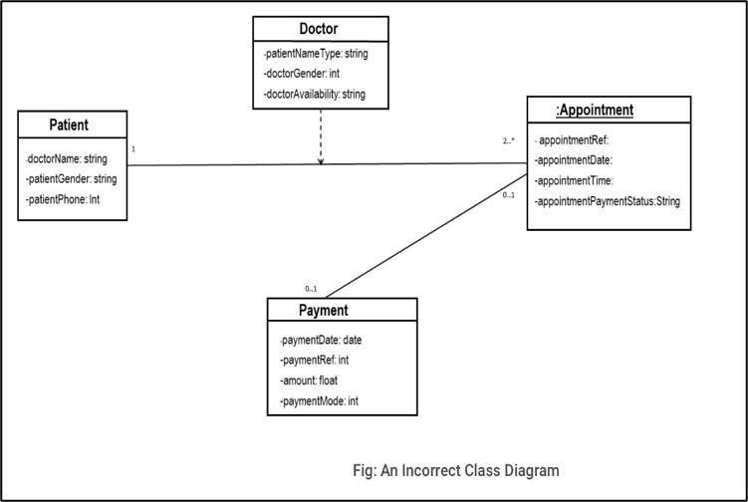

## Chapter-5

### EXPERIMENTS AND RESULT

1. Admin page

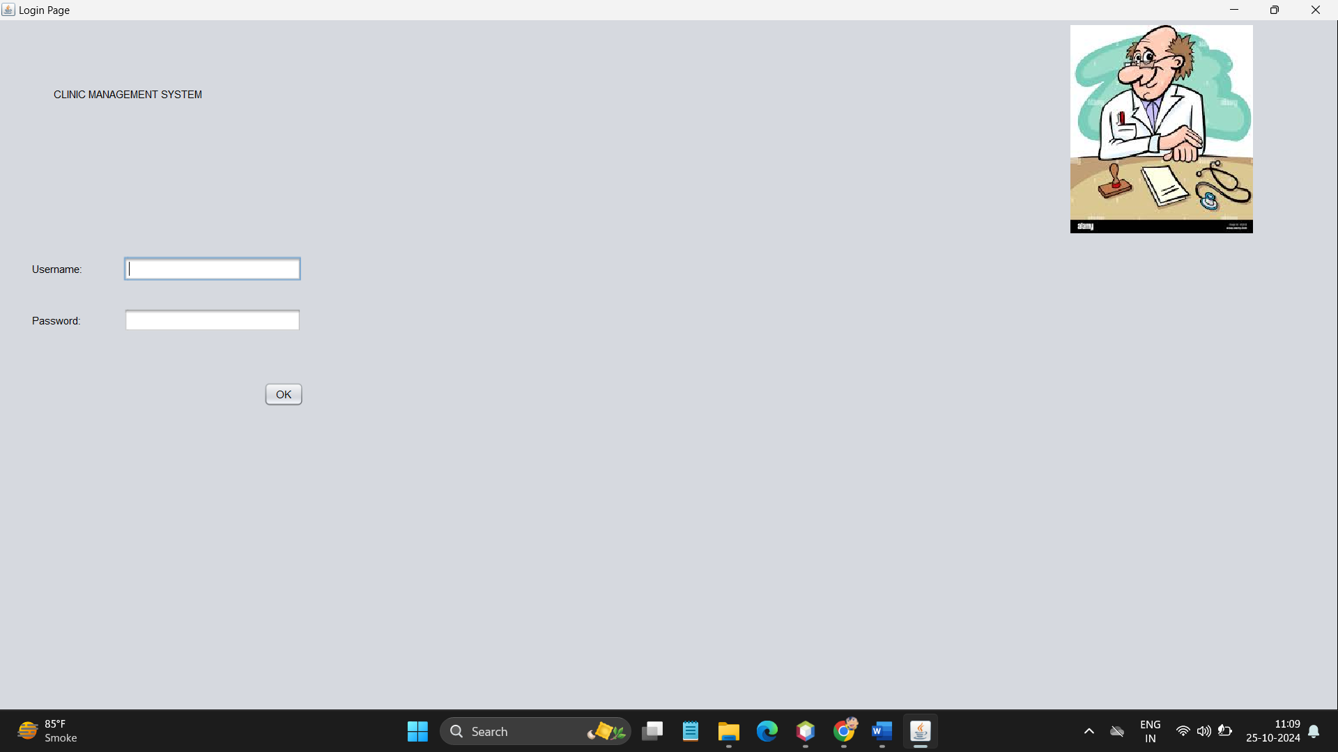

FIGURE NO. 1

1. Menu page

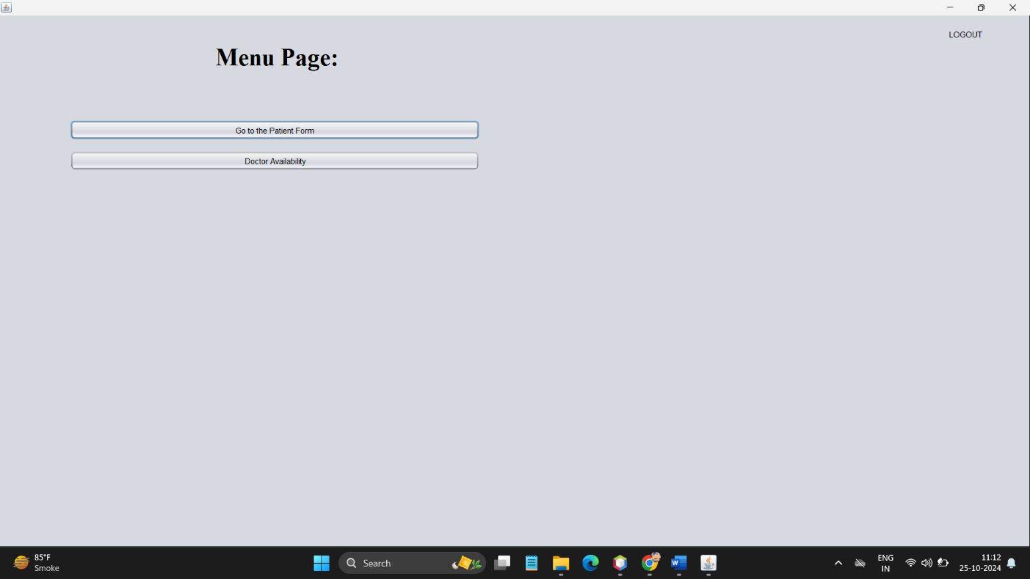

FIGURE NO. 2

1. Patient form

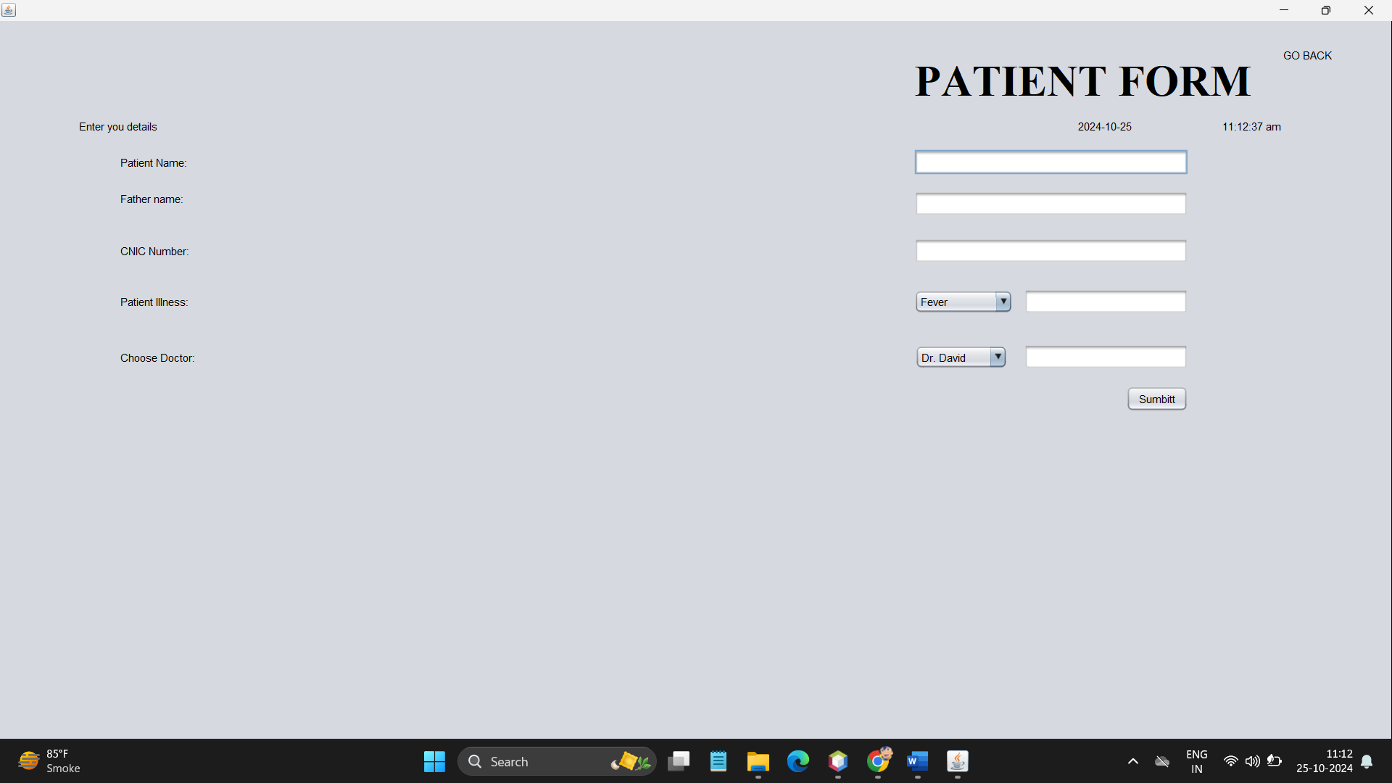

FIGURE NO. 3

1. Doctor availability

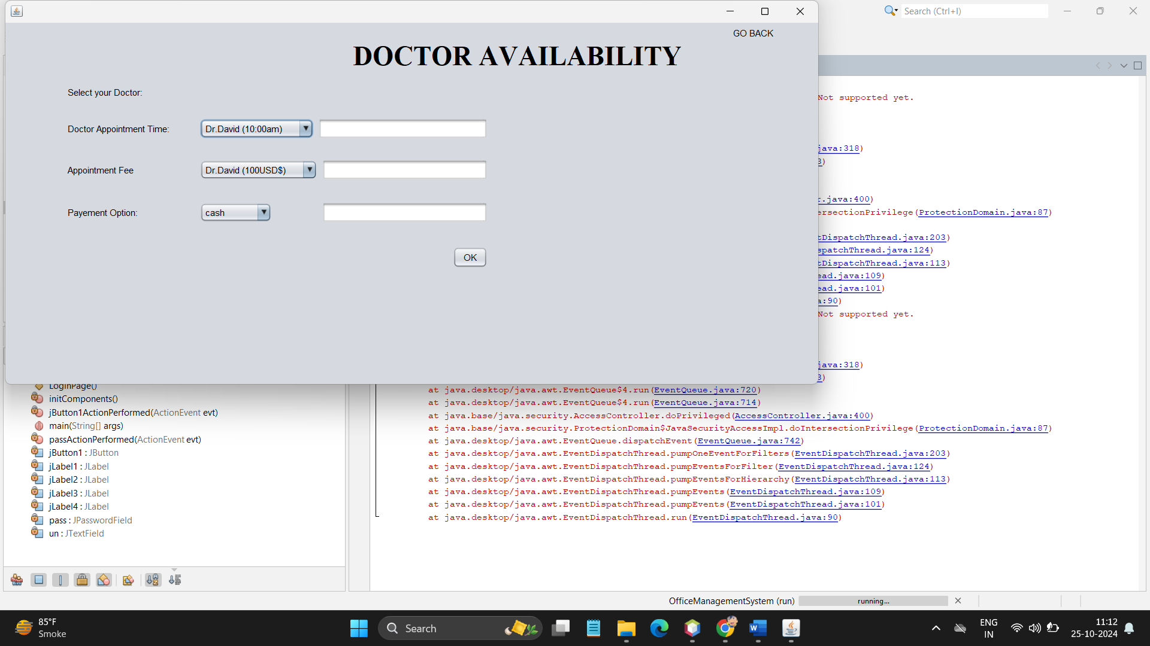

FIGURE NO. 4

## Chapter-6

### CONCLUSION AND FUTURE WORK

##### Conclusion:

The Clinic Doctor Appointment System (CDAS) has proven to be a valuable tool for both patients and healthcare providers, streamlining the appointment scheduling process, enhancing communication, and improving overall clinic efficiency. Through usability testing, efficiency analysis, and user satisfaction surveys, it was determined that the CDAW effectively meets users' needs in terms of usability, efficiency, and satisfaction.

Key findings from the experiment include:

* + Users found the CDAW to be intuitive and easy to navigate, though some minor usability issues were identified.
  + Participants were able to complete tasks on the CDAW efficiently, with most reporting satisfaction with the booking process and access to medical records.
  + Overall user satisfaction with the CDAW was high, with users appreciating its user- friendly design and convenience.

##### Future Work:

Moving forward, several areas for future work and improvement have been identified:

1. Enhanced Usability: Addressing the minor usability issues identified during testing to further improve the user experience.
2. Additional Features: Incorporating additional features based on user feedback, such as personalized care options, telemedicine integrations, and mobile app development.
3. Performance Optimization: Continuously optimizing the performance of the CDAW to ensure fast loading times and responsiveness across various devices and internet connections.
4. Security Enhancements: Implementing additional security measures to further protect patient data and ensure compliance with healthcare regulations.
5. User Engagement: Developing strategies to increase user engagement with the CDAW, such as proactive appointment reminders, patient education resources, and feedback mechanisms.

**REFERENCES**

1. **John Doe. (2022). *Clinic Management System in Java*. GitHub Repository. Retrieved from** [**https://github.com/johndoe/clinic-management-system**](https://github.com/johndoe/clinic-management-system)
2. • University of XYZ. (2020). *Hospital Appointment System Project Using Java and MySQL*. Project Documentation. Retrieved from https://universityxyz.edu/project-repository/hospital-appointment-system-java
3. • Jane Smith. (2019). *Appointment Booking System Using JavaFX*. GitHub Repository. Retrieved from <https://github.com/janesmith/appointment-booking-system-javafx>
4. • ABC University. (2021). *Online Medical Appointment Scheduling System*. Project Documentation. Retrieved from https://abcuniversity.com/med-appointment-project-docs
5. • David Lee. (2023). *Patient Management System in Java with GUI*. GitHub Repository. Retrieved from <https://github.com/davidlee/patient-management-system>